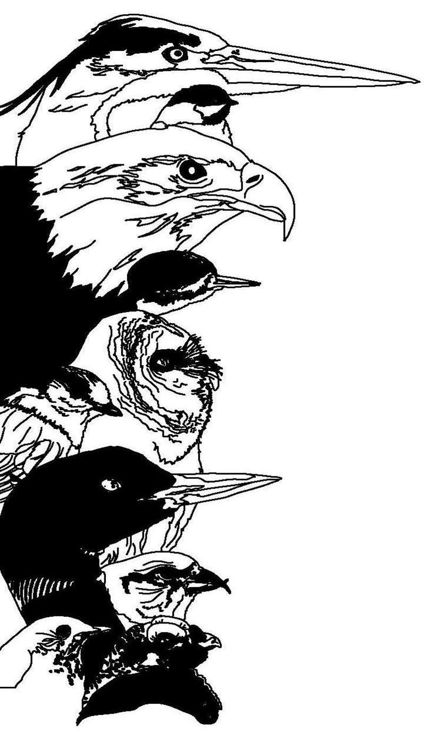
Registration Form for the

11th Great Adirondack Birding Celebration
Paul Smith's College VIC
Paul Smiths, NY 12970

31 May – 2 June 2013

Name: ____________________________________________  Address: __________________________________________  State: __________________Country: _______ ZIP: ________  Phone: ___________________________________________  Email: ____________________________________________ |  | To register, mail completed form with check to:  Paul Smith's College VIC  8023 State Route 30  Paul Smiths  New York 12970  Make checks payable to Paul Smith's College VIC. For information: 518-327-6241
Check any of the events you plan to attend (not included in the registration fee):

___ Friday - Birding Across the Adirondacks Field Trip, $70 additional fee (includes transportation and lunch)

Check any of the events you plan to attend (INCLUDED in registration fee):
___ Friday Evening Lecture and Reception
___ Saturday Catered Lunch (Vegetarian available)
___ Saturday Evening Lecture and Reception
With a full registration, you may attend 1 Field Trip per day:

Saturday Field trips | First Choice | Second Choice | Sunday Field Trips | First Choice | Second Choice
Beginner Birder Workshop | ________ | ________ | Beginner Birder Workshop | ________ | ________
Birding by Ear | ________ | ________ | Birding by ear | ________ | ________
Bloomingdale Bog | ________ | ________ | Bloomingdale Bog | ________ | ________
Intervale Lowlands | ________ | ________ | Intervale Lowlands | ________ | ________
Little Clear Pond (loons) | ________ | ________ | Little Clear Pond (loons) | ________ | ________
Madawaska Flow | ________ | ________ | Madawaska Flow | ________ | ________
Spring Pond Bog | ________ | ________ | Spring Pond Bog | ________ | ________
Whiteface Mountain | ________ | ________ | Whiteface Mountain | ________ | ________
Field trip meeting times and locations will be provided with your registration confirmation.

Registration Fees Per Person (check all that apply) |  |  | Fee Schedule
 | Three-day Registration (Friday through Sunday, includes Friday reception/lecture; Saturday morning field trip, lunch, and afternoon workshop; Saturday reception/lecture; Sunday morning field trip) |  | $125.00
 | Three-day Registration (Northern New York Audubon member – 10% discount) |  | $112.50
 | Saturday Registration Only (includes morning field trip, lunch, afternoon workshop, evening lecture) |  | $90.00
 | Sunday Registration Only (includes morning field trip) |  | $50.00
 | Friday - Birding Across the Adirondacks Field Trip (not included in GABC registration) |  | $70.00
 | Total Enclosed |  | _________________

