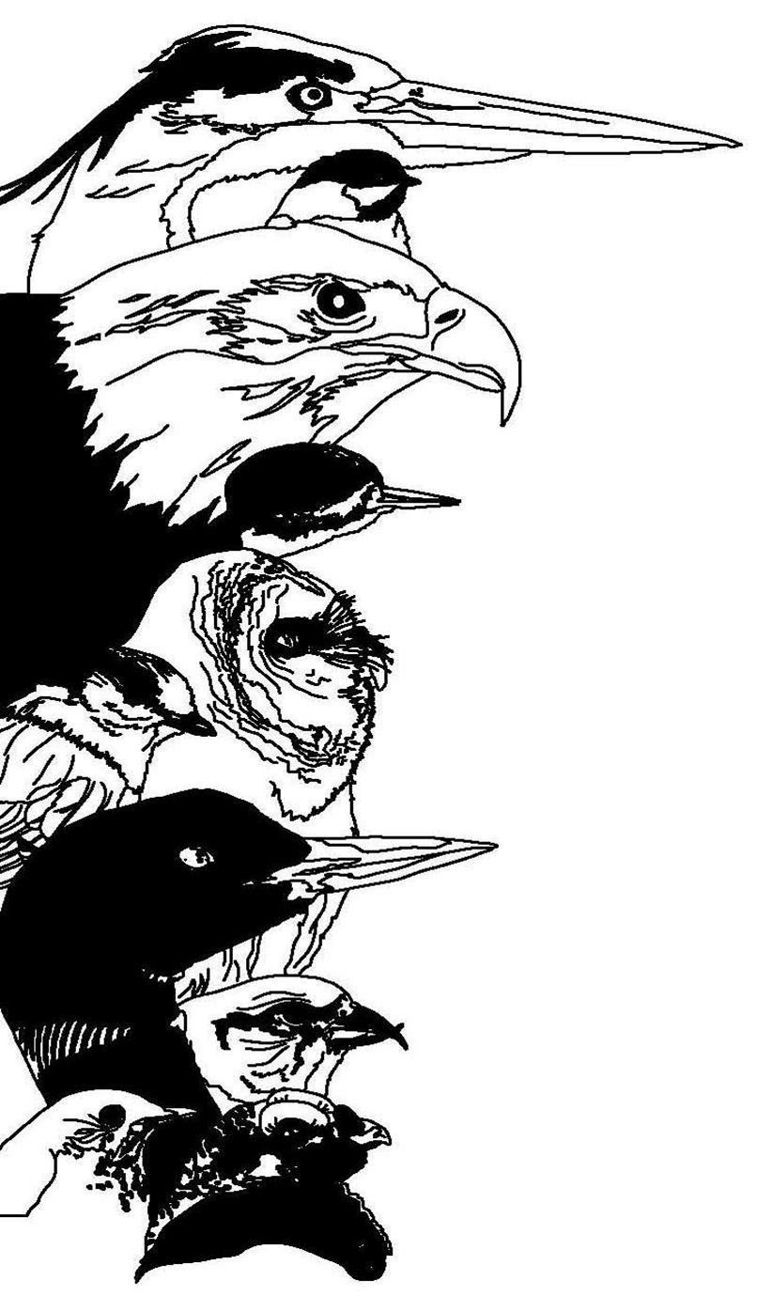

14th Annual Great Adirondack Birding Celebration
June 3 – 5, 2016

Mail completed form with check or credit card information to:

Paul Smith's College VIC
8023 State Route 30
Paul Smiths, New York 12970
(Please fill out one form per person)  Date:_____________________  Name: ____________________________________________________  Address: __________________________________________________  State:_________________________ ZIP: ___________  Cell Phone: ________________________________________________  Email: ____________________________________________________ |  |  | Registration Questions:  Karen Potts  518-327-6249 vicbirding@gmail.com  General Conference Questions: Brian McDonnell  518-327-6234  bmcdonnell@paulsmiths.edu  For More Information, go to:  http://adirondackvic.org/Great-Adirondack-Birding-Celebration-2016.html  NOTE: If you cancel by May 24, you will receive a refund minus a $25 handling fee. After May 24, there are no refunds.  There is a $35 fee for a returned check.
Keynote Speaker on Saturday Evening: “The Adirondack Archipelago” by Dr. Jeremy Kirchman

Friday Trip (Pick One) (Maximum of 16 participants per trip):

___ Birding Across the Adirondacks Field Trip, $75, Trip Leaders: John and Pat Thaxton

___ Birding the Saint Lawrence Valley Field Trip, $75, Trip Leader: Brian McAllister

(Trip fee includes transportation and lunch)

Please indicate your First and Second preference for one trip per morning. Maximum group size is indicated for each trip.
Trip rosters are filled on a first come first serve basis. Space is limited, register early!

Saturday Field Trips | First Choice | Second Choice | Sunday Field Trips | First Choice | Second Choice
Beginner Birder Workshop (15) | _______ | _______ | Beginner Birder Workshop (15) | ______ | _______
Bloomingdale Bog (20) | _______ | _______ | Bloomingdale Bog (20) | ______ | _______
Little Clear Pond for Loons - Paddling Trip (12)* | _______ | _______ | Heaven Hill / John Brown Farm / Henry’s Woods (20) | ______ | _______
Madawaska Flow (20) | _______ | _______ | Madawaska Flow (20) | ______ | _______
Osgood Pond for Water & Boreal Birds - Paddling Trip (12) | _______ | _______ | Osgood Pond for Water & Boreal Birds - Paddling Trip (12) | ______ | _______
Spring Pond Bog (20) | _______ | _______ | Spring Pond Bog (20) | ______ | _______
Whiteface Mountain (20) | _______ | _______ | Whiteface Mountain (20) | ______ | _______
Day of trip registration is on a space available basis. Please call 518-327-6234 for trip openings.
Field trip meeting times and locations will be provided with your registration confirmation.
*Voyageur canoes are provided by MAC’s Canoe Livery.

Fee Schedule
(Only one discount may be used)

 | Ala Carte Fees | Friends of the VIC OR Northern NY Audubon Member  (10% Discount) |  | Friends of the VIC Warbler  (50% Discount)
Friday All Day Field Trip | __ $75 | __ $68 |  | __ $38
All Saturday Morning Field Trips | __ $40 | __ $36 |  | __ $20
All Sunday Morning Field Trips | __ $40 | __ $36 |  | __ $20
Beginner Birder Workshop  (Saturday or Sunday Morning) | __ $30 | __ $27 |  | __ $15
Osgood Pond: bring your own canoe or rent a tandem canoe for $15 per person
Whiteface Mountain Trip Toll Road Fee  (Signed NYS ORDA waiver also required on day of trip.) | __ $10 | __ $10 |  | __ $10
Birding By Ear Workshop (Saturday Afternoon) | __ $20 | __ $18 |  | __ $10
Saturday Catered Lunch at the VIC | __ $12 | __ $12 |  | __ $12
Total Enclosed (Paid by Check or Cash) | ___________ | ___________ |  | ___________
5% Additional Fee for Payment by Credit Card | ___________ | ___________ |  | ___________
Total Credit Card Charge | ___________ | ___________ |  | ___________

Make Checks Payable To: Paul Smith’s College VIC

Credit Card Information (VISA, MC, Discover or AMEX):

Card Number: ___________________________

Expiration Date: _________________________

Security Code: __________________________

Registered Participants:
- Registration desk open 6:30 am to 5 pm daily during the event.

- Registration for one or more trips includes entry to Dr. Kirchman’s Saturday evening lecture and reception.

- Continental breakfasts are pay as you go and include coffee, Danish and fresh fruit.

- Friday lunch, which is part of the trip fee, includes a sandwich, fresh fruit, chips, dessert and bottled water. Vegetarian and vegan sandwiches will be available.

- Saturday lunch fee is an extra $12. Catered buffet lunch includes sandwiches, salads and beverage. Vegetarian and vegan sandwiches will be available. Reservations requested.

- For local accommodations information, please go to:

http://www.saranaclake.com/stay or http://www.lakeplacid.com/lodging

Thank you to Northern New York Audubon for their sponsorship!

